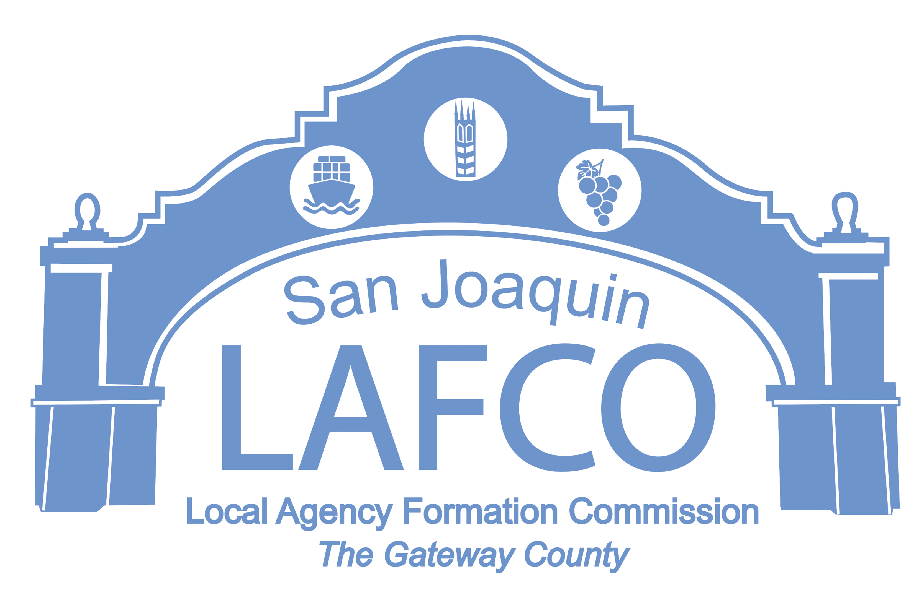
Balancing Community and Commerce
44 N. SAN JOAQUIN STREET SUITE 374 STOCKTON, CA 95202 209-468-3198

THE SAN JOAQUIN LOCAL

AGENCY FORMATION

COMMISSION (LAFCo)

MEETING SCHEDULED FOR

MAY 11, 2023
HAS BEEN

CANCELLED

