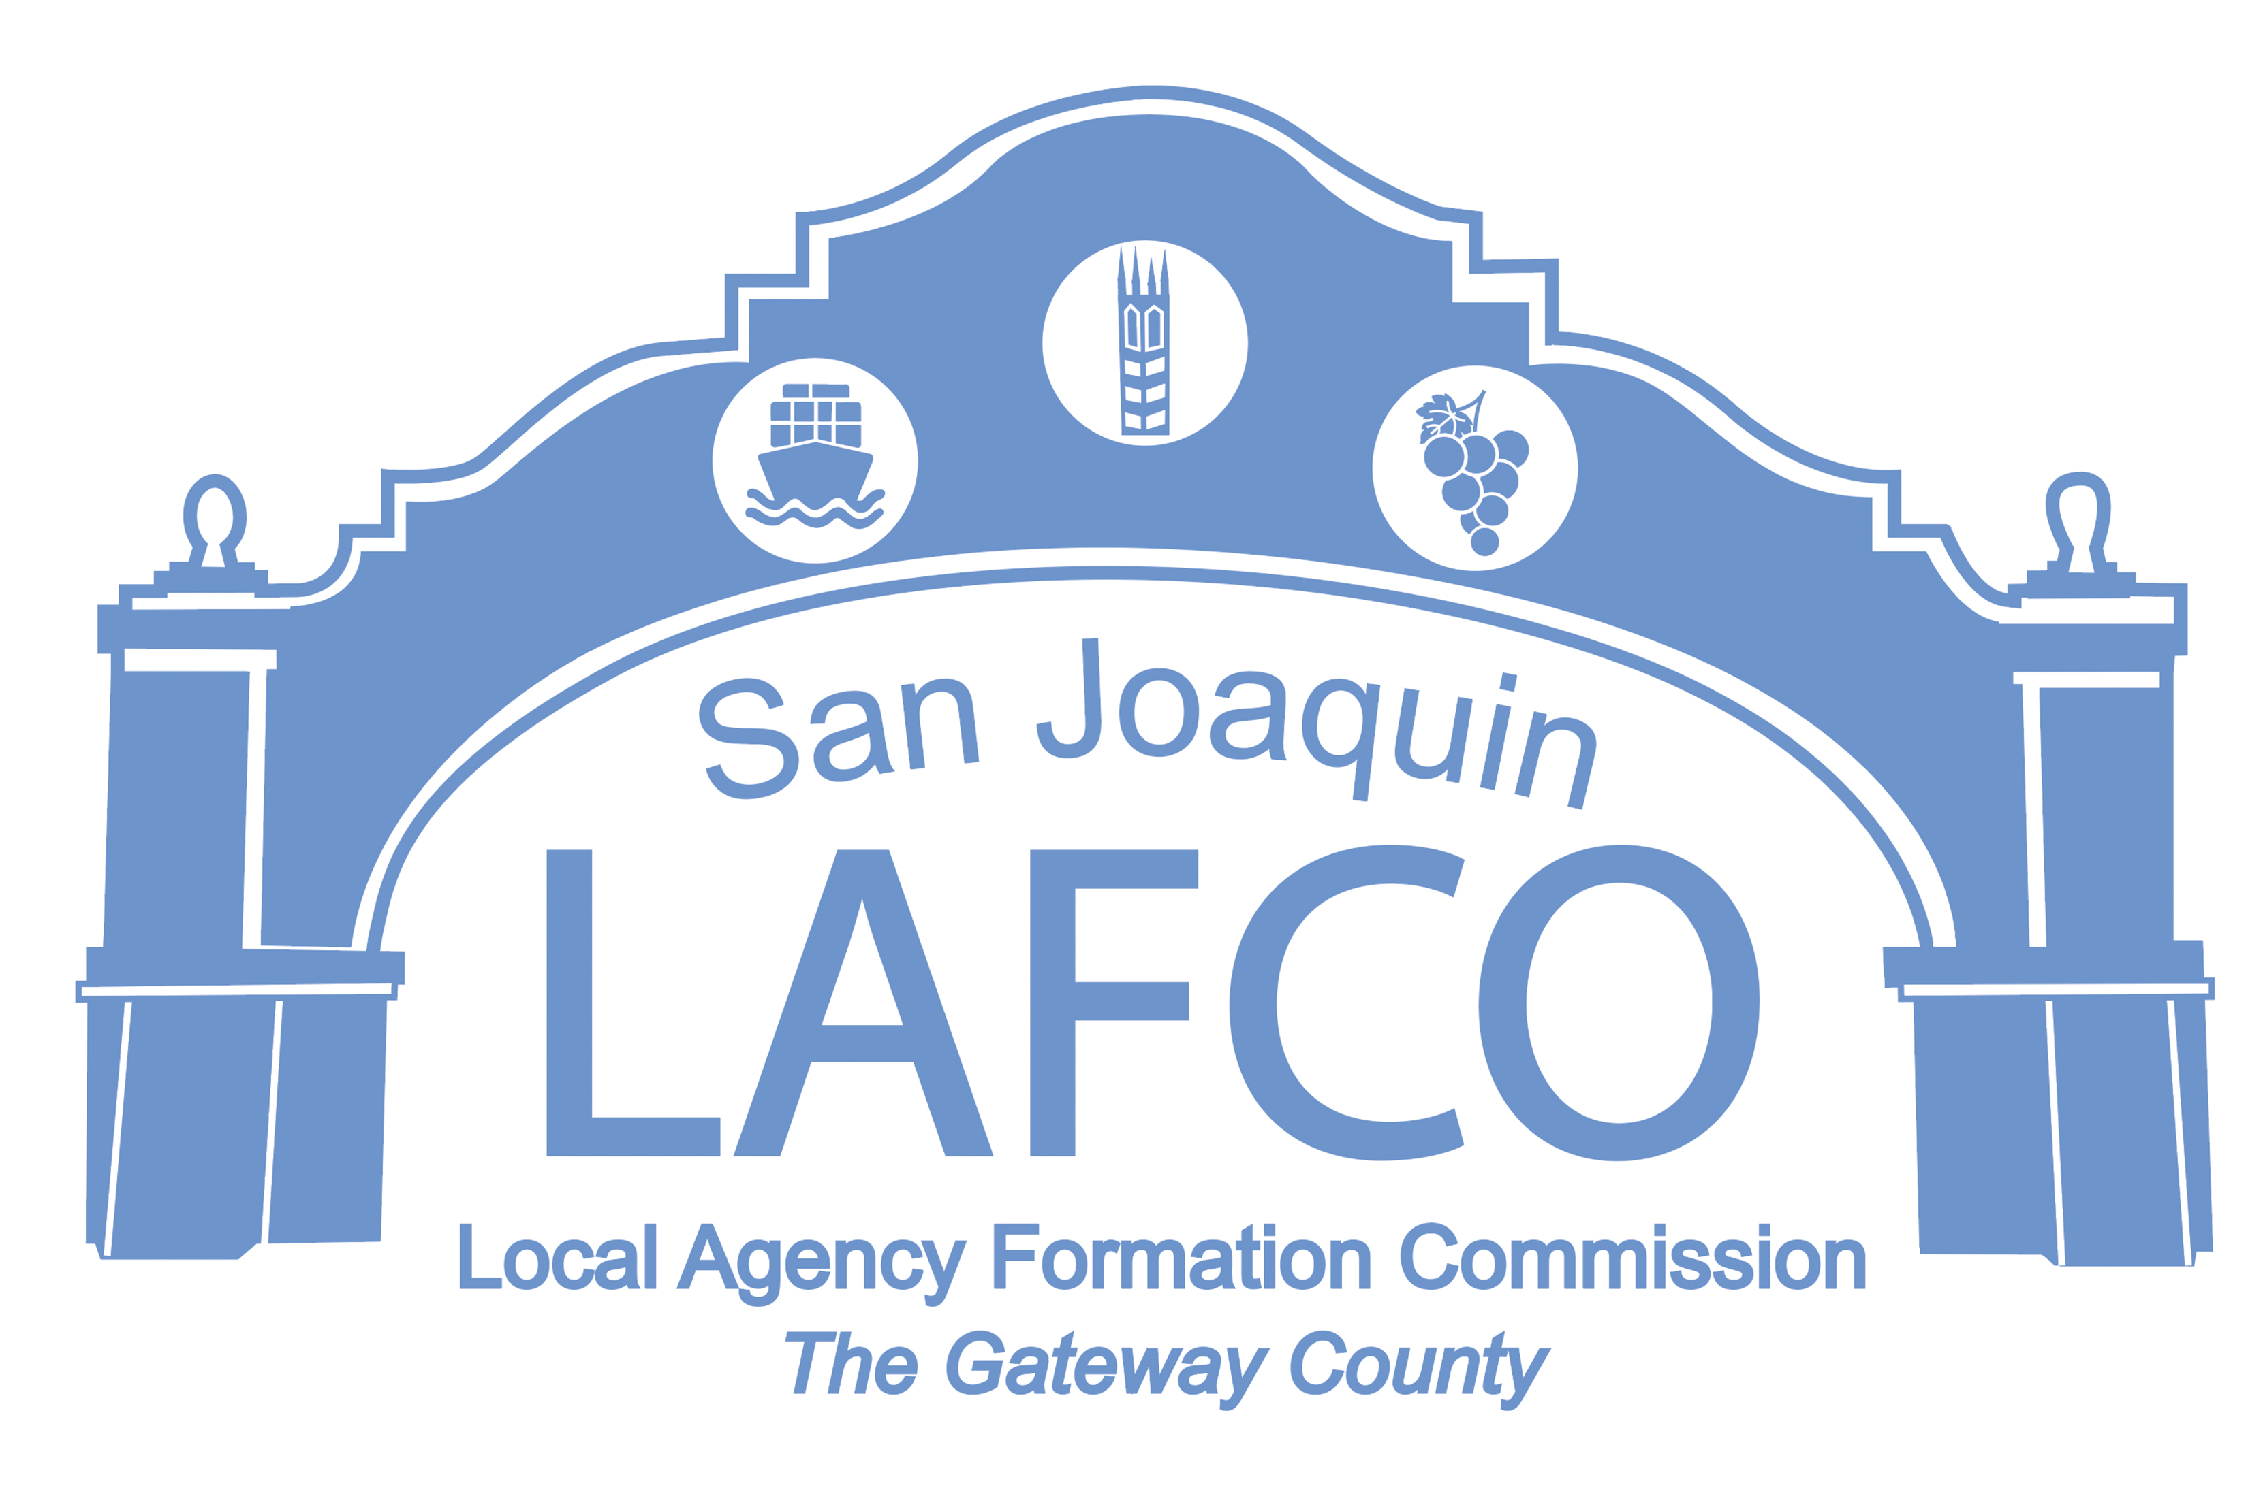
Balancing Community and Commerce
44 N. SAN JOAQUIN STREET SUITE 374 STOCKTON, CA 95202 209-468-3198

NOTICE OF PUBLIC HEARING
SINGH PETROLEUM REORGANIZATION TO THE CITY OF LATHROP (LAFC 20-24)

NOTICE IS HEREBY GIVEN that on Thursday, September 12, 2024, at 9:00 A.M. in the Chambers of the Board of Supervisors on the 6th Floor, 44 North San Joaquin Street, Stockton, California, the San Joaquin Local Agency Formation Commission (LAFCo) will conduct a regularly scheduled public hearing to consider the Singh Petroleum Reorganization to the City of Lathrop.

The City of Lathrop has submitted an application to annex approximately 21.7 acres into the City of Lathrop consisting of two (2) parcels on the southwest corner of Roth Road and Manthey Road, 11293 South Manthey Road and 169 West Manila Road (APN’s 191-250-06 & 14). A LAFCo alternative may include the annexation of an additional 12.02 acres consisting of three parcels, 11401, 11591 and 11555 South Manthey Road (APN’s 191-250-07, 09 & 10), Vicinity Map attached.

The proposed annexation by the City of Lathrop is necessary for the development of a regional travel center. The center will be built to accommodate both the existing alignment (Phase I) and foreseeable realignment of Manthey Road (Phase II) as well as improvements to Roth Road. The travel center includes regional travel serving uses, consisting of gas and diesel fueling facilities for passenger and commercial vehicles, 16,668 sq. ft. travel center building that includes two (2) Quick Serve Restaurants (QSR) with one (1) drive-through pad, a 13,846 sq. ft. sq ft 4 bay full service truck and automobile repair facility, and off street parking for motorist and commercial truck operators.

The site will remain within the Lathrop Manteca Fire Protection District and detach from County Road District 3. The LAFCo alternative would utilize South Manila Road as a boundary of the proposed annexation area and remain within the LMFD and detachment from County Road District 3.

If you have any questions or need more information, please call the LAFCo business phone (209) 468-3198, email the Executive Officer at jhightower@sjgov.org or visit our website at www.sjlafco.org.

BY ORDER OF THE SAN JOAQUIN
LOCAL AGENCY FORMATION COMMISSION
Dated: August 22, 2024 JD Hightower, Executive Officer

