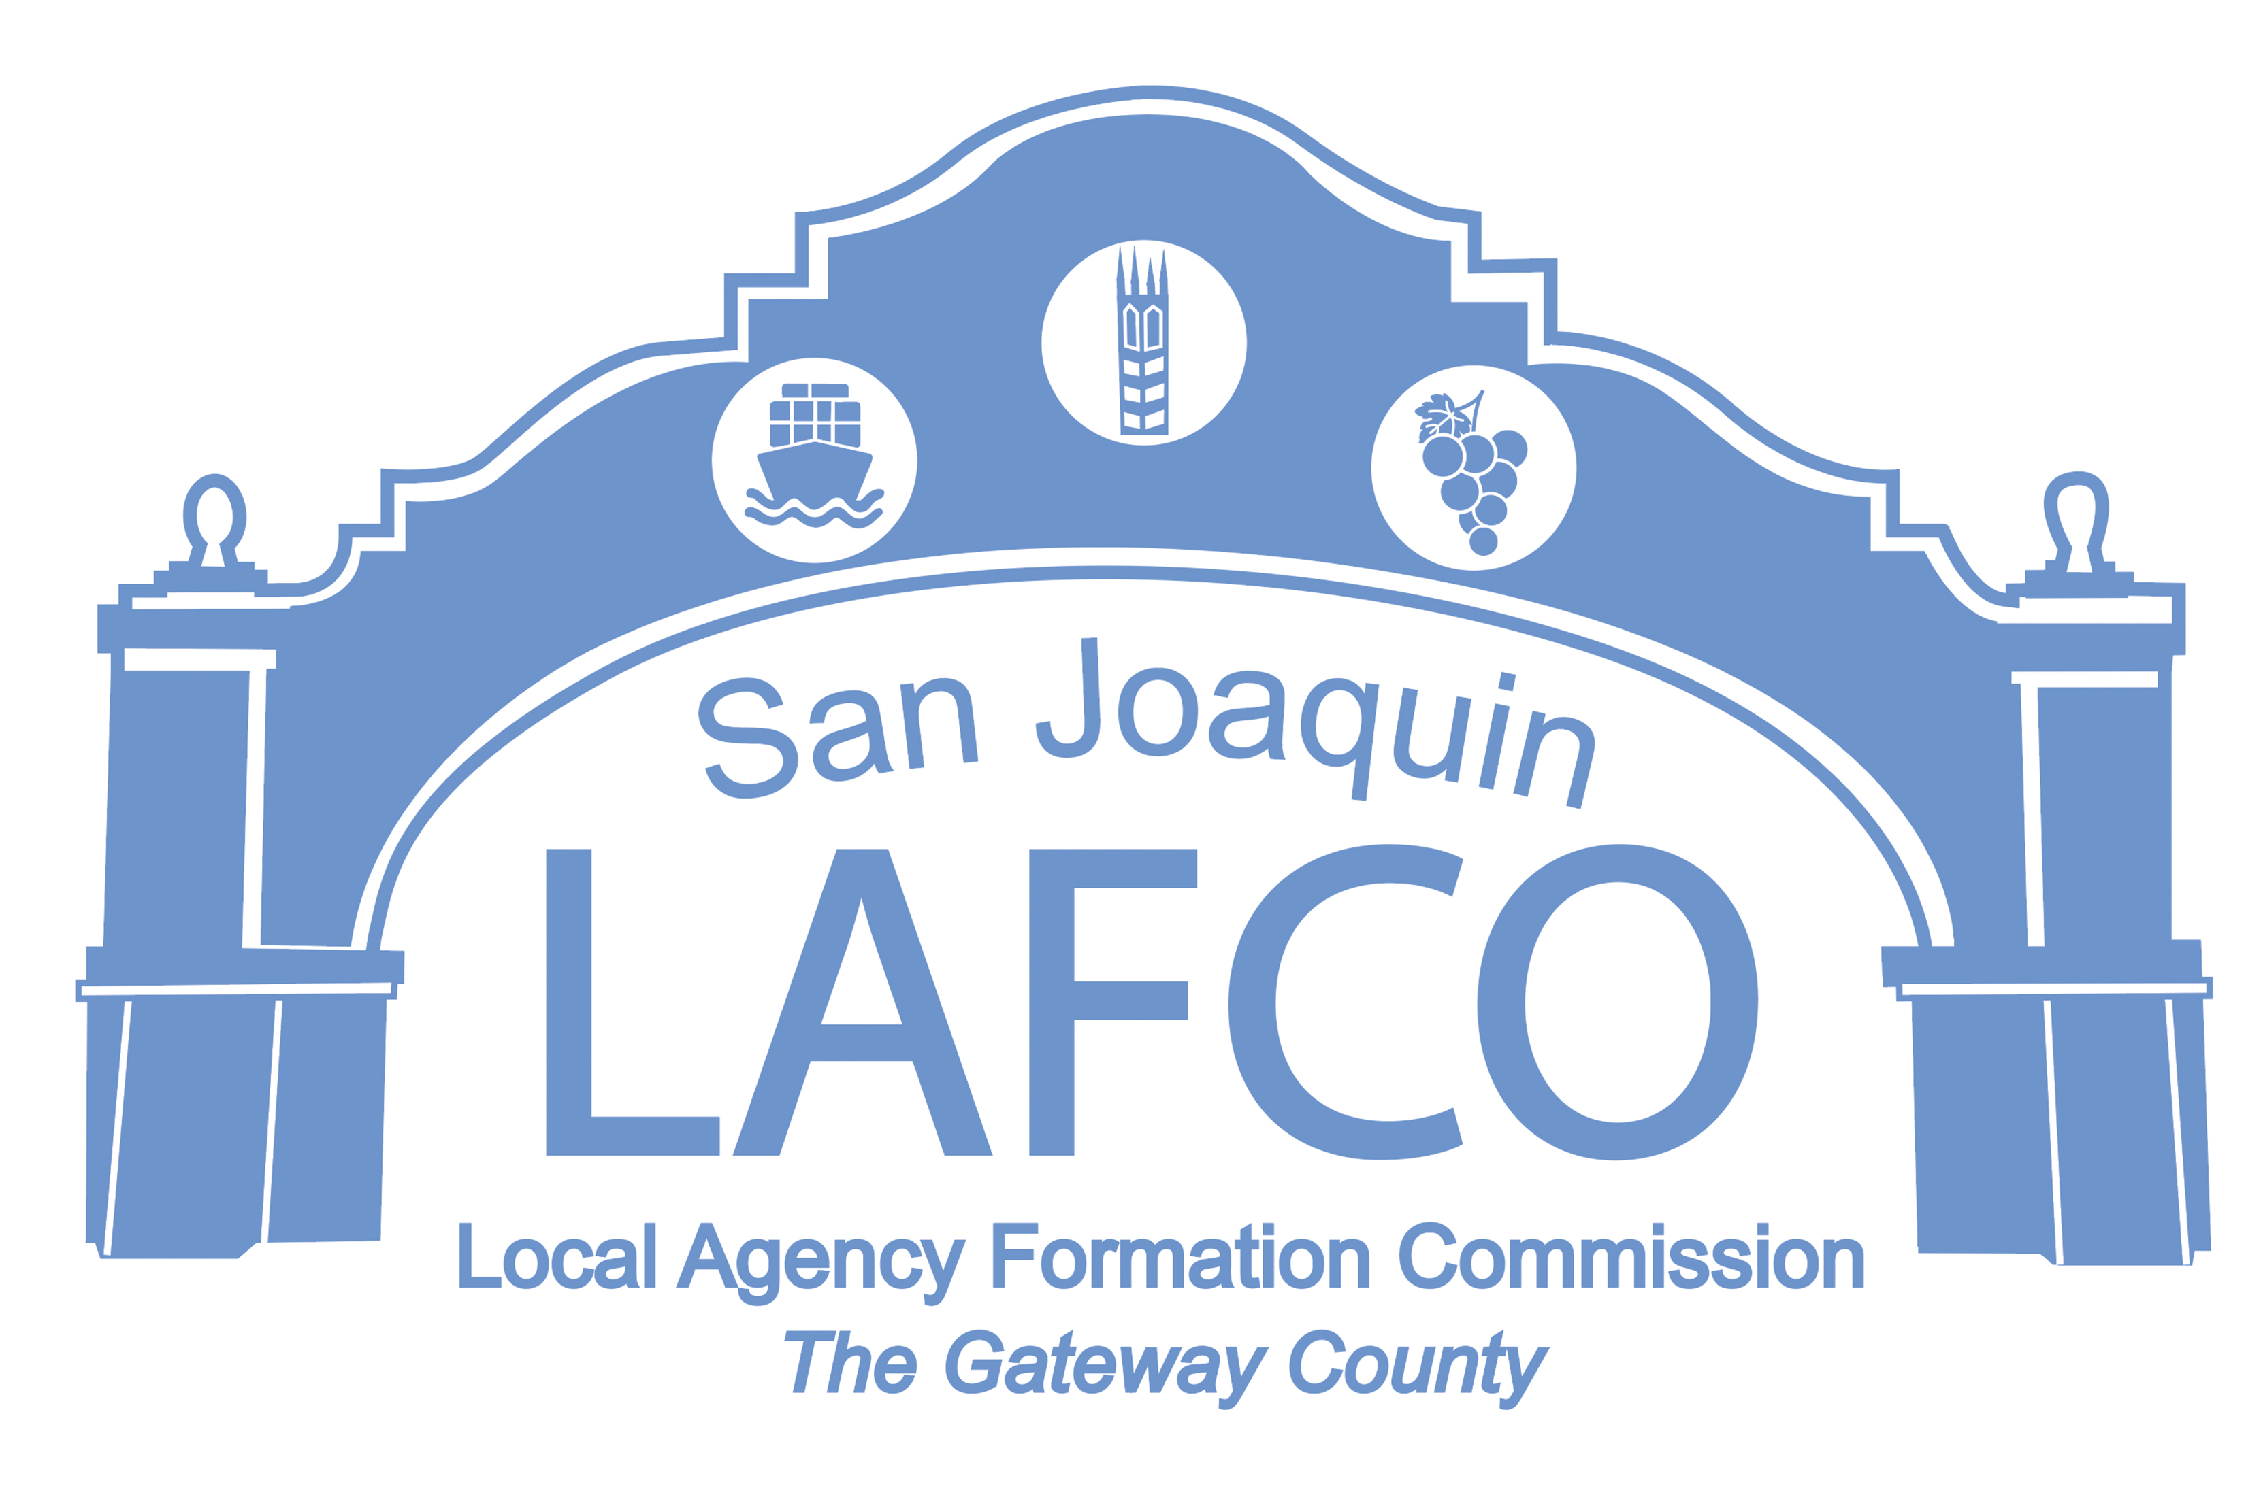
Balancing Community and Commerce
44 N. SAN JOAQUIN STREET SUITE 374 STOCKTON, CA 95202 209-468-3198

NOTICE OF PUBLIC HEARING
HIGHWAY 12 INVESTORS, LLC/LILVAL PROPERTIES, LTD. ANNEXATION TO SAN JOAQUIN COUNTY COMMUNITY SERVICE AREA 31 (CSA-31), FLAG CITY
(LAFC 16-24)

NOTICE IS HEREBY GIVEN that on Thursday, August 8, 2024, at 9:00 A.M. in the Chambers of the Board of Supervisors on the 6th Floor, 44 North San Joaquin Street, Stockton, California, the San Joaquin Local Agency Formation Commission (LAFCo) will conduct a regularly scheduled public hearing to consider the Highway 12 Investors, LLC & Lilval Properties, LTD. Annexation to San Joaquin County CSA 31, aka Flag City.

San Joaquin County Public Works Department has submitted an application to annex approximately 4.96 acres into CSA-31 31 consisting of one (1) parcel 15314 North Thornton Road (APN 025-190-31). The annexation will allow the development of a truck parking facility with 96 truck parking spaces, 14 employee parking spaces and a 4,900 square foot repair facility. The proposed annexation to CSA-31, Zone W will allow the site to receive domestic water treated for nitrate reduction and storm water drainage. The site will remain within all existing districts, i.e., the Woodbridge Fire Protection District, Woodbridge Irrigation District and served by the San Joaquin County Sheriff’s Department.

The proposed annexation is adjacent to the existing CSA-31 boundaries on two sides, to the southwest (Pilot Travel Center) and southeast (Loves Country Stores California). The proposed annexation would extend water and storm drainage lines to the property. The County has determined that there is adequate capacity in both systems for CSA-31 to serve the proposed annexation. San Joaquin County, as lead agency adopted a Mitigated Negative Declaration for the project, including annexation to CSA-31

If you have any questions or need more information, please call the LAFCo business phone (209) 468-3198, email the Executive Officer at jhightower@sjgov.org or visit our website at www.sjlafco.org.

BY ORDER OF THE SAN JOAQUIN
LOCAL AGENCY FORMATION COMMISSION
Dated: July 18, 2024 JD Hightower, Executive Officer

